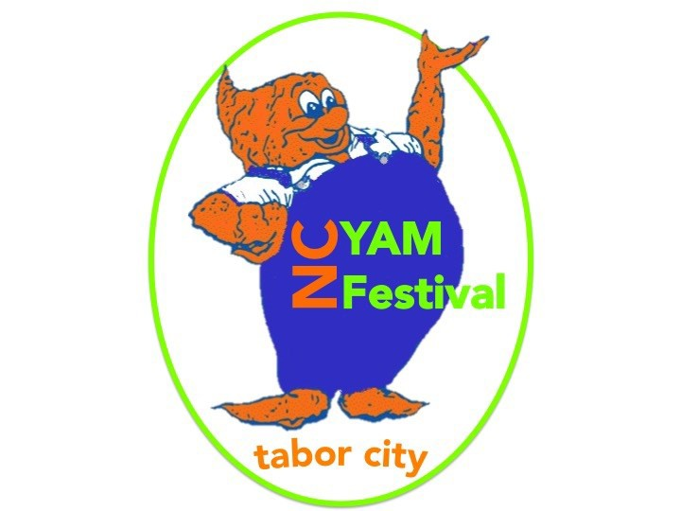
Tabor’s Got Talent
For Official Use Only
Received By:
Paid:

Tuesday, October 24th, 2016
South Columbus High School Auditorium 6:00 pm
Yam Festival Talent Show Registration Form

Individual Entry Group Entry
*If Group act, all names must be listed individually below)

Name Phone Email

**Please print clearly. Please do not use an email address that you do not check often. If more than five in a group act, please
add the name and info to the back of the page.

Type of Talent (please check one category):
Dance Skit Song Other

If other please specify:

Title of Performance or Group Name:

Brief Description of Act (Lip Sync, Dance, Magic, Vocal,
etc):

Will performance include props? If Yes Please explain:
Special setup of arrangement required?

If you have any special needs or requests not listed please be sure to list them below:

Rules: Acts must submit pictures with application, performance cannot exceed 3 minutes, all performances will be responsible for own props, sound check at 4:30 on the 18th, Microphones will be provided, All decisions will be final, winning acts will not be able to participate in next years show but may be asked to perform. By submitting this application, you are acknowledging your commitment to participate in Tabor’s Got Talent 2016. You understand that your image may appear on the Social Media, news papers, and our website. If for any reason you cannot attend please let us know the week before the show. Cash prizes will be handed out the night of the show.
For More Information:
Email Applications: Erin.E.Mincey@gmail.com Or mail to: Tabor’s Got Talent Attn: Erin Mincey
P.O Box 446, Tabor City NC 28463
Please Call Erin Mincey @ 910-625-6753 Or email Erin.E.Mincey@gmail.com

