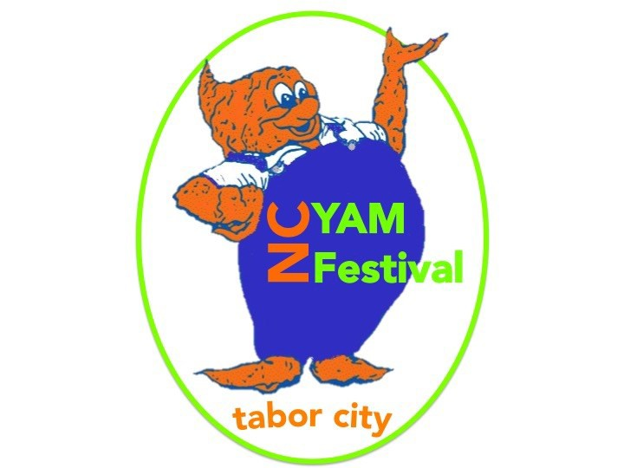
32nd Annual N.C. Yam Festival Parade & Festival
Saturday, October 28th, 2017

Keep guidelines for parade/festival day

Parade Rules/Guidelines:
- The N.C. Yam Festival manages the parade and all decisions made by the organization are final.
- Applications must be received by Friday, October 6th, 2017for consideration.
- Unsigned applications will not be accepted.
- All fees paid/postmarked/delivered after 10-6/2017will be subject to a $25.00 late fee.
- Parade check-in: Date: Saturday, October 28th, 2017
Time: 8:00am-9:30am (any after 9:30 am may be subject to dismissal) Location: behind Tabor City Elementary School
- All children 12 & under must be in a vehicle or float; not walking.
- Entries will be judged on appearance, enthusiasm, and creativity
- Please maintain spacing and limit stops.
- Public consumption of alcohol is not allowed per City Ordinance.
- NO REFUNDS. This is a rain or shine event.
- All Parade entries must maintain a 2 mile per hour speed unless stopping to perform briefly.
- All entrants are responsible for their car and signs with the exception of the (Professional Float)

*********** Parade Check-In and Line up***********

Parade Route: 10:00 a.m. Originating Stake Rd., right on
Bell, right on Hickman, left on 3rd, right on Lewis, right on 5th, left on Wall Street.

Parade Check-in: Check in will be 8am—9:15am on October 28th behind Tabor City Elementary School at the Visitor’s Center

For more information contact: The Greater Tabor City Chamber of Commerce Email: tccofc@yahoo.com

