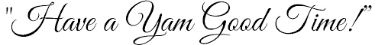
OCTOBER 15, 2016

DIVISIONS:
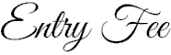

$110 per contestant
(Optional Photogenic Award extra)
- Baby Miss: 0-12 months
- Mini Miss: 13-24 months
- Tiny Miss: 2-3 years
- Petite Miss: 4-6 years
- Little Miss: 7-8 years
- Junior Miss: 9-10 years
- Young Miss: 11-13 years
- Teen Miss: 14-16 years
- Queen: 17- 21 years
- Mrs.: 20+, married only

- ALL CONTESTANTS ARE REQUIRED TO SIGN A MORALITY CONTRACT BEFORE COMPETING. This will be available at registration and the night of rehearsal. If there are any questions regarding the content of the contract prior to registration please contact the Director (contact information on page 3).
- Pageant is open to residents of North Carolina and South Carolina
- NC Yam Festival Royalty will not have an all-expenses paid reign. It is up to the queens to provide everything themselves (cars for parades, entry fees for parades – unless otherwise noted, clothing, shirts, signs, etc). We will strive to make sure you save as much money as possible. We hope you understand and if there are any questions about expenses please feel free to ask!
- Awards Given: Division Winners receive a rhinestone round crown, embroidered satin sash, trophy, & gift. Runners-Up & Participants will receive a trophy (Baby – Petite will also receive a rhinestone tiara).
Optional winners will receive a trophy.
- The 2016 Yam Festival Queen and Teen will also be invited to attend the Carolina Dogwood Festival in Statesville (held in April 2017) and the NC Rhododendron Festival in Bakersville (held in June 2017). These events are not mandatory but offered to reigning Queen and Teen and does require either the Pageant Director and/or parent as chaperones.
- It is VITAL & HIGHLY IMPORTANT for the winners to attend the following events listed, if there are any changes you will be notified as soon as possible by the director. The NC Yam Festival Pageant Committee will do everything they can to minimize the cost of the required parades, but there may be some small cost required by the contestants. As a queen you will be representing the town of Tabor City and the NC Yam Festival and it is your duty to be a symbol of the town and its festivities as well as local festivals and events.

- NC Yam Festival Taste of Tabor ( Thursday, October 20, 2016 , 6-10pm)
(Location TBA & ONLY the 2016 Royalty’s ticket will be paid for)
- NC Yam Festival Parade – line up @ 10:00 am (Saturday, October 22nd) - (float provided)
- Tabor City Christmas Parade - line up @ 5:00pm (Thursday, December 1) - (car needed)
- NC Strawberry Festival, parade & pageant (Saturday, May 6th, 2017) – (float provided)
  - parade line-up @ 1:00pm & pageant @ 6:30 pm at West Columbus High School
- NC Watermelon Festival, parade & pageant (Saturday, July 2017 - TBA) – (car needed)
  - Parade line-up @ 10 am & pageant @ 6:30pm at West Columbus High School

~ If necessary we will have meetings, however it is hard for everyone to get together.
Therefore, a newsletter will be mailed out periodically to all the queens with details about upcoming pageants and events! ~

(ALL OF THE ABOVE PARADES & EVENTS ARE FREE TO THE QUEENS, YOU MUST BUY CAR SIGNS & PROVIDE YOUR OWN CAR …
IF POSSIBLE THERE WILL BE PARADES WE WILL BE ABLE TO ALL RIDE TOGETHER ON FLOATS TO MINIMIZE COST FOR EVERYONE.

- 2016 NC Yam Festival Royalty will be asked to keep a scrap book of their appearances, list of community service, other pageant visits, parade appearances etc. These will be on view the following year and will also qualify one 2016 queen the chance to reign on the 2017 court as Ambassador (chosen by director according to most events attended/participated in).

- NOTE: This is not a HIGH Glitz event! This is a community focused pageant. Therefore, no full fake hair, no fake nails, no fake teeth, no excessive makeup, etc. If you have questions or concerns regarding this please let me know. The judges will be notified of the rules and regulations of this pageant also and deductions in points will be made accordingly by their discretion.
- REQUIRED!!! ALL Contestants will be showcased in the Opening Number, this is not a judged event but it is important to make a good first impression on the judges, by showing your stage presence, etc. Each contestant is required to wear long blue jeans, matching shoes (no flip flops and you must wear shoes) and the North Carolina Yam Festival T-Shirt (sold at the Tabor City Library). Additional embellishments are up to the contestants, but not required
- Required Areas of Competition:
  - For Baby – Petite: Casual Wear (40%) & Beauty (60%)
  - For Little – Queen: Interview (40%), Talent (30%), & Beauty (30%)
  - For Mrs.: Interview (40%), Casual Wear (30%), & Beauty (30%)

- Optional Areas: Photogenic is $10.00. Photogenic (open to all contestants),

- PHOTOGENIC: Either black and white or color. No HIGH GLITZ pictures allowed, however touchups are allowed. This optional is completely up to the contestant, you may do a picture book, picture board, decorative item with pictures on it, or whatever you choose. It will be judged on presentation and pictures. There will be two awards given, Baby-Petite divisions & then Little – Mrs. divisions (SEE LAST PAGE FOR PICUTURE EXAMPLES)
- INTERVIEW: For Little-Mrs. Divisions only. Little-Young Miss contestant will each meet with the judges for 3 minutes and Teen-Mrs. Contestants will each meet with the judges for 5 minutes. Make sure outfit is age appropriate. For Little & Junior divisions Sunday dress is accepted but not restricted to, pant/skirt suit is also accepted; for Young – Mrs. divisions skirt/pant suit/dressy attire is highly recommended!

- CASUAL WEAR: For Baby-Petite & Mrs. only: Dress age appropriate, dressy, neat and stylish, making sure outfit fits properly. No mid-drift showing, if so points will be deducted! Can either be custom made or off the rack. Embellishments are highly recommended. No theme requirement!
- TALENT: For Little-Queen divisions only: CD’s only allowed, all music must be cued and only one song per CD. Please do not let talent exceed 4 minutes! CD’s should be marked with contestant name, division, & contestant number. CD’s must be turned in the night of rehearsal to assure that all CD’s work with the sound equipment and the person doing the sound will be responsible for them. Make sure to have a backup CD the night of rehearsal and the pageant!

- BEAUTY: Divisions Baby & Mini should have Sunday dress attire, with matching socks and shoes, glitz pageant dresses NOT recommended. Tiny & Petite Division must have a short dress with matching shoes & socks, can be glitzy. Little Miss Division may have short or floor length pageant dress, must have matching shoes & socks if short. Divisions Junior – Mrs. must have floor length dress. Pageant dresses may be as glitzy as you like, but please be age appropriate! Make sure all dresses fit and compliment the contestant.
- Scholarship Recipients: Applies ONLY to the Teen & Queen Winners. Teen will receive $250 & Queen will receive $750. This will be received in the form of a check after they have completed their year of reign as long as they did not enter another pageant without permission, attended all required events unless excused by director, and did not show any unnecessary demeanor during the year.
- Birthdate Rules: The contestant’s age must be so the date of the pageant and the age they are that date determines the category they will be in the night of the pageant. If there are any questions or concerns please ask. PLEASE BE HONEST!!
- Grace Period: This pageant is open to any contestant whether you have a title or not, however, if you win you will not be allowed to run in another pageant (and still be able to carry the NC Yam Festival Title) unless the pageant date is within 60 days of the NC Yam Festival Pageant and special permission is given by the director. PLEASE REPSECT THIS! DETAILS LISTED IN MORTALITY CONTRACT!
- Score Sheets: They will be released after the pageant to the contestants. These are given back to make enhancements, not to be compared to everyone else’s scores. They should be taken as a tool to help you improve in the areas the judges saw necessary. If returning the score sheets becomes as issue we will discontinue this.
The judge’s scores are final!
- THERE ARE NO CASH PRIZES FOR CONTESTANTS OTHER THAN SCHOLARSHIP RECIPIENTS
- Contestants and/or parents are not allowed to approach the judges at any time during the pageant.
- Information on whom or how many are competing in any age group will not be disclosed by the director until the newspaper release or the night of rehearsal.
- Photogenic pictures, talent CDS, and score sheets can be picked up after the pageant at the auditors table after crowning.

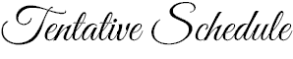

- Registration/Pageant Application Deadline:
Sunday, September 11th, 2016
(Meeting will be held @ 4:00 pm at the Tabor City Visitors Center)
Please call for directions, questions, or if you will be unable to attend. We will be reviewing all guidelines and pageant information. It is very important to be at this meeting if you have questions, otherwise submit your completed application any time before or on Sunday, September 11, 2016.
- Final Deadline is midnight!
- Pageant Rehearsal:
Thursday, October 13th @ 6:30 pm - South Columbus High School
- Contestant numbers will be given out (You are responsible for this, there will be no extras!!!)
- Each contestant will receive a program of the pageant
- A schedule of interviews will be given
- Contestants will receive 2 parent passes; you must pay $5 for a hairdresser or any backstage help unless they have a pass, there will be someone monitoring the halls for passes. (Hairdressers may come to do hair before pageant and will not be charged as long as they are gone before the pageant begins. If they plan on helping you throughout the pageant they will need a pass. If there is only one parent then the hairdresser may use it. Bottom line – Hairdresser/backstage help must have a pass! Please feel free to ask if there are any questions about this!)
- There will be a run through of pageant, allowing contestants to walk the stage and perform talent. (Bring talent music to make sure it works on the system, make sure to have extra copies for rehearsal & the night of the pageant)
- Pageant Day: Saturday October 15th, 2016
- Doors will open at SCHS @ 2:00pm
- Turn in Photogenic entries by 3:00 pm
- NOTE: Side door will be locked at all times. NO ONE is to enter or exit here unless it is an EMERGENCY. Everyone must enter and exit through school’s main entrance. There will be someone monitoring this area.
- Contestant numbers should be worn on the left side at waist area if at all possible, for each area of competition except talent!
- Interviews for Little-Mrs. will begin at 3:00pm @ SCHS (A schedule will be given out the night of rehearsal so you can better prepare)
- Pageant will begin @ 6:00pm
- Admission is $8, program included

Please mail completed Contestant Application, Competition Sheet with total (make sure bottom of paper is signed as well), a wallet size photo of contestant, & Fees to:

Suzette Leonard •140 Lake Tabor Drive. • Tabor City, NC 28463

I accept checks, money orders, certified checks and/or cash (make checks payable to NC YAM FESTIVAL) / A receipt will be generated!
Please note: There will be a $35 returned check fee for all returned checks.
Contestant cannot compete until money is received by application deadline, September 11th, 2016. Wallet size photos will be printed in one or more newspapers announcing the pageant & in the programs.
Contact information: Cell: 910.641-1598 Home: 910.653-5948 Email: leonardmom1@yahoo.com

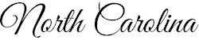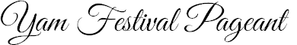

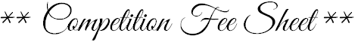

Required Competition ……………………………..$110.00

Optionals:
Photogenic (all divisions)……… $10.00 ________

Total: ________

- I understand that all fees are non-refundable and I have read and agree to abide by all pageant rules listed. I further agree not to hold the North Carolina Yam Festival Pageant, directors, staff, or facilities of pageant responsible for any injuries, losses, damages, thefts, or accidents that may occur at the North Carolina Yam Festival pageant, or while traveling to or from any event. I understand that judges’ decisions are final! Any act of bad sportsmanship from contestants or family members will NOT be tolerated and will result in disqualification without refund. By affixing your signature to this contract you grant permission to the North Carolina Yam Festival Pageant system the right to use any and all pictures taken prior to, during, or after the event for advertising and/or marketing purposes and to allow said pictures to be posted on our website, you will first be notified if this occurs. There will be a $35.00 service charge for all returned checks. The North Carolina Yam Festival Pageant reserves the right to refuse entry to anyone. All entries are non-refundable and are at the discretion of the director.

Signature of parent (or contestant if of legal age): ____________________________________________________________________

Printed Name of Contestant: _______________________________________________________________

Date: ___________________________________________________________

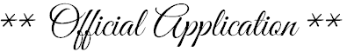

Division: _________________________________

Full Name: ______________________________________________ Age: __________ Date of Birth: _____________________
Parent’s Names (Husband for Mrs.): ____________________________________________________________________________________
Address: ____________________________________________________________________________
City: _______________________________ State: ____________ Zip Code: _______________
County: _______________________________ Phone Number(s): ______________________________________
Hair Color: ___________________________ Eye Color: ________________________________
Favorite Food: _________________________________ Favorite TV Show: ____________________________________________
School Currently Attending: _____________________________________________________________ Grade: ______________
Most Admired Person & Why:
__________________________________________________________________________________________________________
__________________________________________________________________________________________________________
Interesting Information about yourself:
__________________________________________________________________________________________________________
__________________________________________________________________________________________________________
Future Goals:
_________________________________________________________________________________________________________
_________________________________________________________________________________________________________
Why would like to be a North Carolina Yam Festival Queen? ______________________________________________________________________________________________________________________________________________________________________________________________________________________________
Sponsored By: ________________________________________________________________________________________________________
For Photogenic:
Notice these pictures are of the same girl!
We are not objected to touchups however High/Full Glitz is not accepted.
Please feel free to contact the director if there are any further questions.

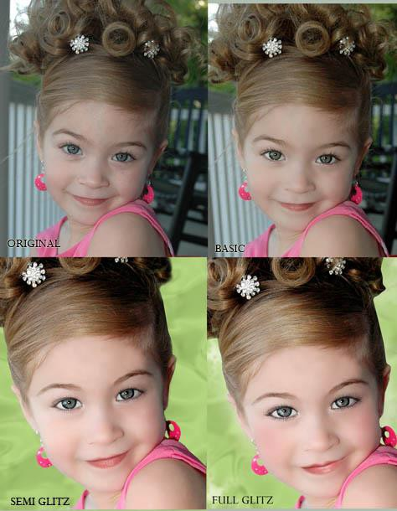

All are accepted except FULL GLITZ ↑

