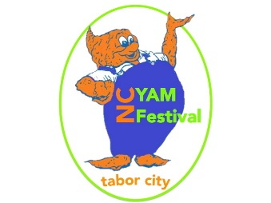

2017 NC Yam Festival

ADULT ART SHOW AND PHOTOGRAPHY SHOW
Rules and Guidelines
2017

Please attach a note that says “Not for Sale” if your artwork is not for sale. Otherwise all artwork will be considered for purchase.

The North Carolina Yam Festival Art Show is scheduled for Friday, October 27 from 10:00 a.m. until 4:00 p.m. and Saturday, October 28 from 11:00 a.m. until 4:30 p.m. in the fellowship hall of the Tabor City Baptist Church located on Live Oak Street in Tabor City. Kelly Jones will serve as chairperson for this year’s show. General information and rules are as follows:

REGISTRATION:

Registration for all entries will be on Wednesday, October 25th, from 1:30 until 4:30 p.m. in the fellowship hall at Tabor City Baptist Church. Each entry should be clearly labeled and signed with one label permanently attached to the back and another label paper clipped for turning after judging. Labels will be available at registration. It is suggested that exhibitors arrive by 4:00 p.m. in order to complete registration by 4:30. Any photo submitted may not have been assembled digitally. Touch up such as brightness and tones are allowed. Only 5 entries per artist are allowed in all categories.

Registration………………….Wednesday, October 25
Judged……………….……….Wednesday, October 25
Show…………………………Friday, October 27 10:00 a.m. – 4:00 p.m.
Saturday, October 28 11:00 a.m. – 4:30 p.m.

ENTRY FEES
Entry Fees will be waived; each artist may submit up to five entries.

CATEGORIES:

Painting

Oil, acrylic, watercolor, or tempera

Drawing

Pencil, ink, charcoal, pastel, crayon, and markers

Collage

Sculpture / Pottery / Ceramics / Mosaics

Any artwork containing glass will be displayed on a table or floor.

AWARDS:

PLEASE NOTE THAT CASH AWARDS WILL BE GIVEN ONLY FOR BEST OF SHOW.

Professional Art
Best of Show ($50)
Second and Third Place

Amateur Art
Best in Show ($50)
First Place
Second and Third Place

Photography
Best in Show ($50)
First Place / Professional

Two Purchase Awards

Ribbons……First, Second, Third, and Honorable Mention
Tri-Color……Best in Show

For other information, call: Kelly Jones 642-5168

